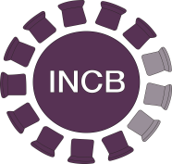
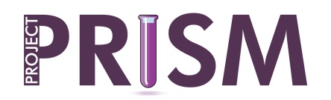

PP Notice No. 1/2026

24 February 2026

FEEDBACK FORM
on cannabidiol (CBD)

To proceed, please identify yourself:

Country: Click here to enter

Agency: Click here to enter the name and address of your agency.

Name: Click here to enter your name

E-mail: Click here to enter your e-mail

COUNTRY: Click or tap here to enter text.

To the extent possible, kindly respond to the following questions:

National regulatory framework

- Is cannabidiol (CBD) controlled in your country?
Yes ☐ No ☐ Unknown ☐

If yes, provide information about the nature of control (as drug precursor, …) and provide details of the law(s) regulating operators dealing in the substance.

Click or tap here to enter text.

- Kindly provide the details of agency(ies) responsible for control of CBD (this would also help to register the agency for use of PEN Online Light).

Click or tap here to enter text.

Operators and Uses

- To the extent possible, kindly provide details of the end-use(s) of CBD in your country and the estimated needs for each end-use.

Click or tap here to enter text.

- To the extent available, kindly provide an indication of the number of companies dealing with CBD in any of the following ways:

 | Number | Quantity (kg)
Total number of companies dealing with CBD in any way
Of the total number, indicate:
- Number of companies manufacturing CBD (and the amount manufactured)
- Number of companies importing or exporting CBD
- Number of companies trading CBD domestically
- Number of end-using companies

Use of CBD in clandestine manufacturing

- Kindly provide any evidence or intelligence (even if preliminary) related to the use of CBD for the illicit manufacture of THC, as well as synthetic and semi-synthetic cannabinoids (e.g., HHC, THCP, HHC-O, and other modified structures).

Click or tap here to enter text.

- Any other comments you wish to make

Click or tap here to enter text.

